CAS PY 106

Prelecture Note 31

1. Diffraction
2. Spreading out of a wave when it encounters a single object or opening
3. Double-source equation
4. For two sources a distance d apart, constructive interference occurs when
5. 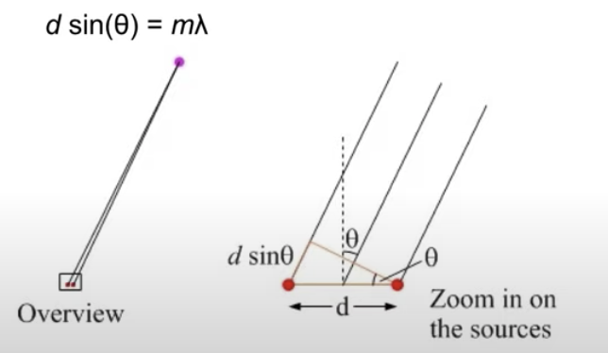
6. Single-slit equation
7. Let’s call the width of the slit a. Each point on the slit acts as a source of waves. For a point a long way from the sources, destructive interference is given by the equation: a \* sin(theta) = m \* lambda
8. 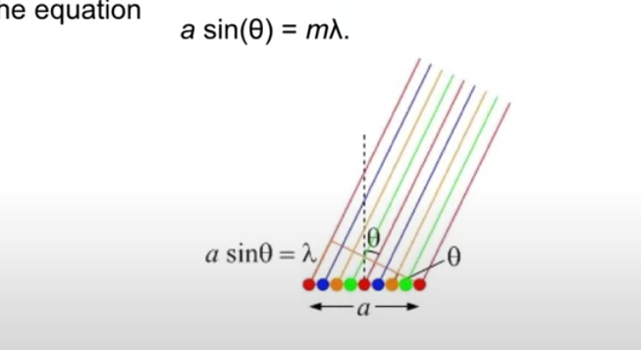
9. The double slit
10. The double slit is a combination of the single slit pattern and the double source pattern
11. 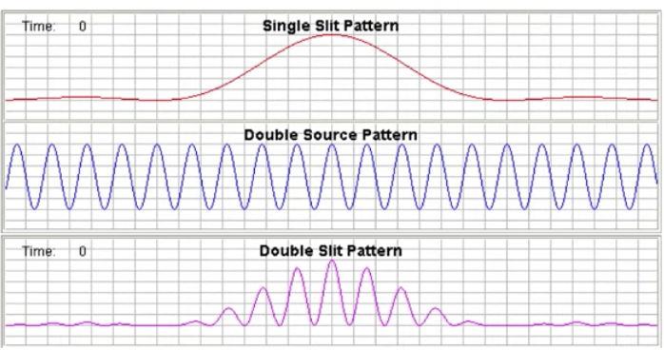
12. If each slit sent out light uniformly in all directions, the peaks in the pattern would be equally bright, as in “double source” picture
13. Instead, each slit sends out a diffraction pattern, with most of the light in the central peak, as in the “single slit” picture
14. Interference between the two diffraction patterns produces the “double slit” pattern shown at the bottom
15. The “double slit” pattern shows missing orders. Peaks predicted by the double-source equation are not present, because they coincide with zeros in the single slit pattern
16. 